Andreas Staier
Piano, Fortepiano, Harpsichord
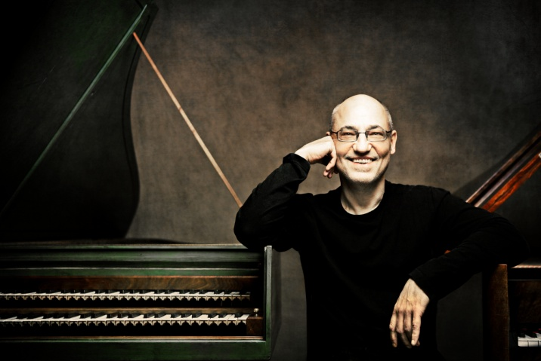
One of the world’s most prominent performers and recording artists, Andreas Staier’s indisputable musical mastery has made its mark on the interpretation of baroque, classical and romantic repertoire. Acknowledged by his peers and a wider audience, Andreas continues to defend intellectual and artistic standards in both known and neglected works for the keyboard.
As a soloist, Andreas Staier performs throughout Europe, North and South America, and Asia with orchestras such as Concerto Köln, Freiburger Barockorchester, the Akademie für alte Musik Berlin, hr -Sinfonieorchester Frankfurt, Orchestre des Champs-Elysées Paris, Le Concert de la Loge, and Orquestra Barroca Casa da Música. On modern piano he is performing regularly with orchestras including the Orchestre Symphonique de Quebec, Rundfunk Sinfonieorchester Berlin, and Yomiuri Nippon Symphony Orchestra.
Andreas has been invited to leading international festivals including the Festival de La Roque d’Anthéron, Festival de Saintes, Festival de Montreux, Edinburgh International Festival, York Early Music Festival, Lufthansa Festival of Baroque Music, Styriarte Graz, Schubertiade Schwarzenberg, Schlweswig Holstein Musik Festival, Bach-Fest Leipzig, Bachtage Berlin, Bachwoche Ansbach and Kissinger Sommer. He has also performed in major venues: Konzerthaus, Wien; Konzerthaus and Philharmonie, Berlin; Kölner Philharmonie; Gewandhaus Leipzig; Alte Oper Frankfurt; Tonhalle Düsseldorf; Wigmore Hall and Royal Festival Hall, London; deSingel, Antwerp; Concertgebouw, Amsterdam; Palais des Beaux Arts, Brussels; Tonhalle, Zürich; Cité de la Musique, Théâtre des Bouffes du Nord, Ircam, and Théâtre des Champs-Elysées, Paris; Teatro della Pergola, Florence; Sala Filarmonica, Roma; Toppan Hall and Suntory Hall, Tokyo; Carnegie Hall and Frick Collection, New York; and is regularly invited as a guest soloist by the BBC.
As a chamber musician, Andreas is performing regularly with keyboard players Alexander Melnikov, Christine Schornsheim and Tobias Koch, violinists Isabelle Faust and Petra Müllejans, and in a piano trio with violinist Daniel Sepec and cellist Roel Dieltiens. He has also worked with the actresses Senta Berger and Vanessa Redgrave as well as Anne Sophie von Otter, Alexei Lubimov and Pedro Memelsdorff, and his musical partnership with the tenor Christoph Prégardien produced numerous lieder recordings (Schubert, Schumann, Mendelssohn, Beethoven and Brahms), all highly acclaimed by international critics.
Andreas has recorded extensively for BMG, Teldec Classics (with whom he had an exclusive contract for seven years) and harmonia mundi France, the latter since 2003. His catalogue boasts numerous awards including a Diapason d’or for his ‘Am Stein vis-à-vis’ with Christine Schornsheim (Mozart), the 2002 Preis der Deutschen Schallplattenkritik and, in 2011, the Baroque Instrumental Gramophone Award for his CPE Bach concerti recording with the Freiburger Barockorchester. His recording of the ‘Diabelli Variations’, received Diapason d’Or, E/Scherzo, G/Gramophone, 10/10 Classica and the BBC Music Magazine’s Disc of the Month, and his selection of 17th century works for harpsichord of both German and French repertoire: '...pour passer la mélancolie', earned him a second Gramophone award in 2013.
Andreas’s most recent releases include a presentation of Schubert’s music for four hands together with Alexander Melnikov, a collection of music inspired by the Iberian Peninsula together with the Orquestra Barroca Casa da Música and a double disc, Ein neuer Weg, for harmonia mundi to mark Beethoven’s 250th anniversary in 2020. Upcoming is a long-awaited presentation of J.S Bach’s Well-Tempered Clavier.

